BYUI v4.0.1 e-badge

Changes in V4.0.1 from v4.0 (Pending Approval)
- Moved joystick and CN1 I2C connector to prevent collision with the joystick plastic cap.
- Fixed joystick footprint to line up with the 3d model.
- Fixed silkscreen errors.
- Changed D14’s (Single Red LED) resistor value to make it brighter.
- Changed buck boost to forced PWM mode (decreases higher frequency ripple)
- Added RC filter to the addressable LEDs power input to lower pulsed current load on power supply.
- Standardized 2.54mm headers so they all look the same.

(All or none of these changes can be used in the V4.0.1 version of the board next semester).

Possible Changes
- Use male 2.54mm pins instead of female on configurable IO.
- Allows pins to be configurable without tweezers.
- Helps distinguish between configurable IO and other headers.
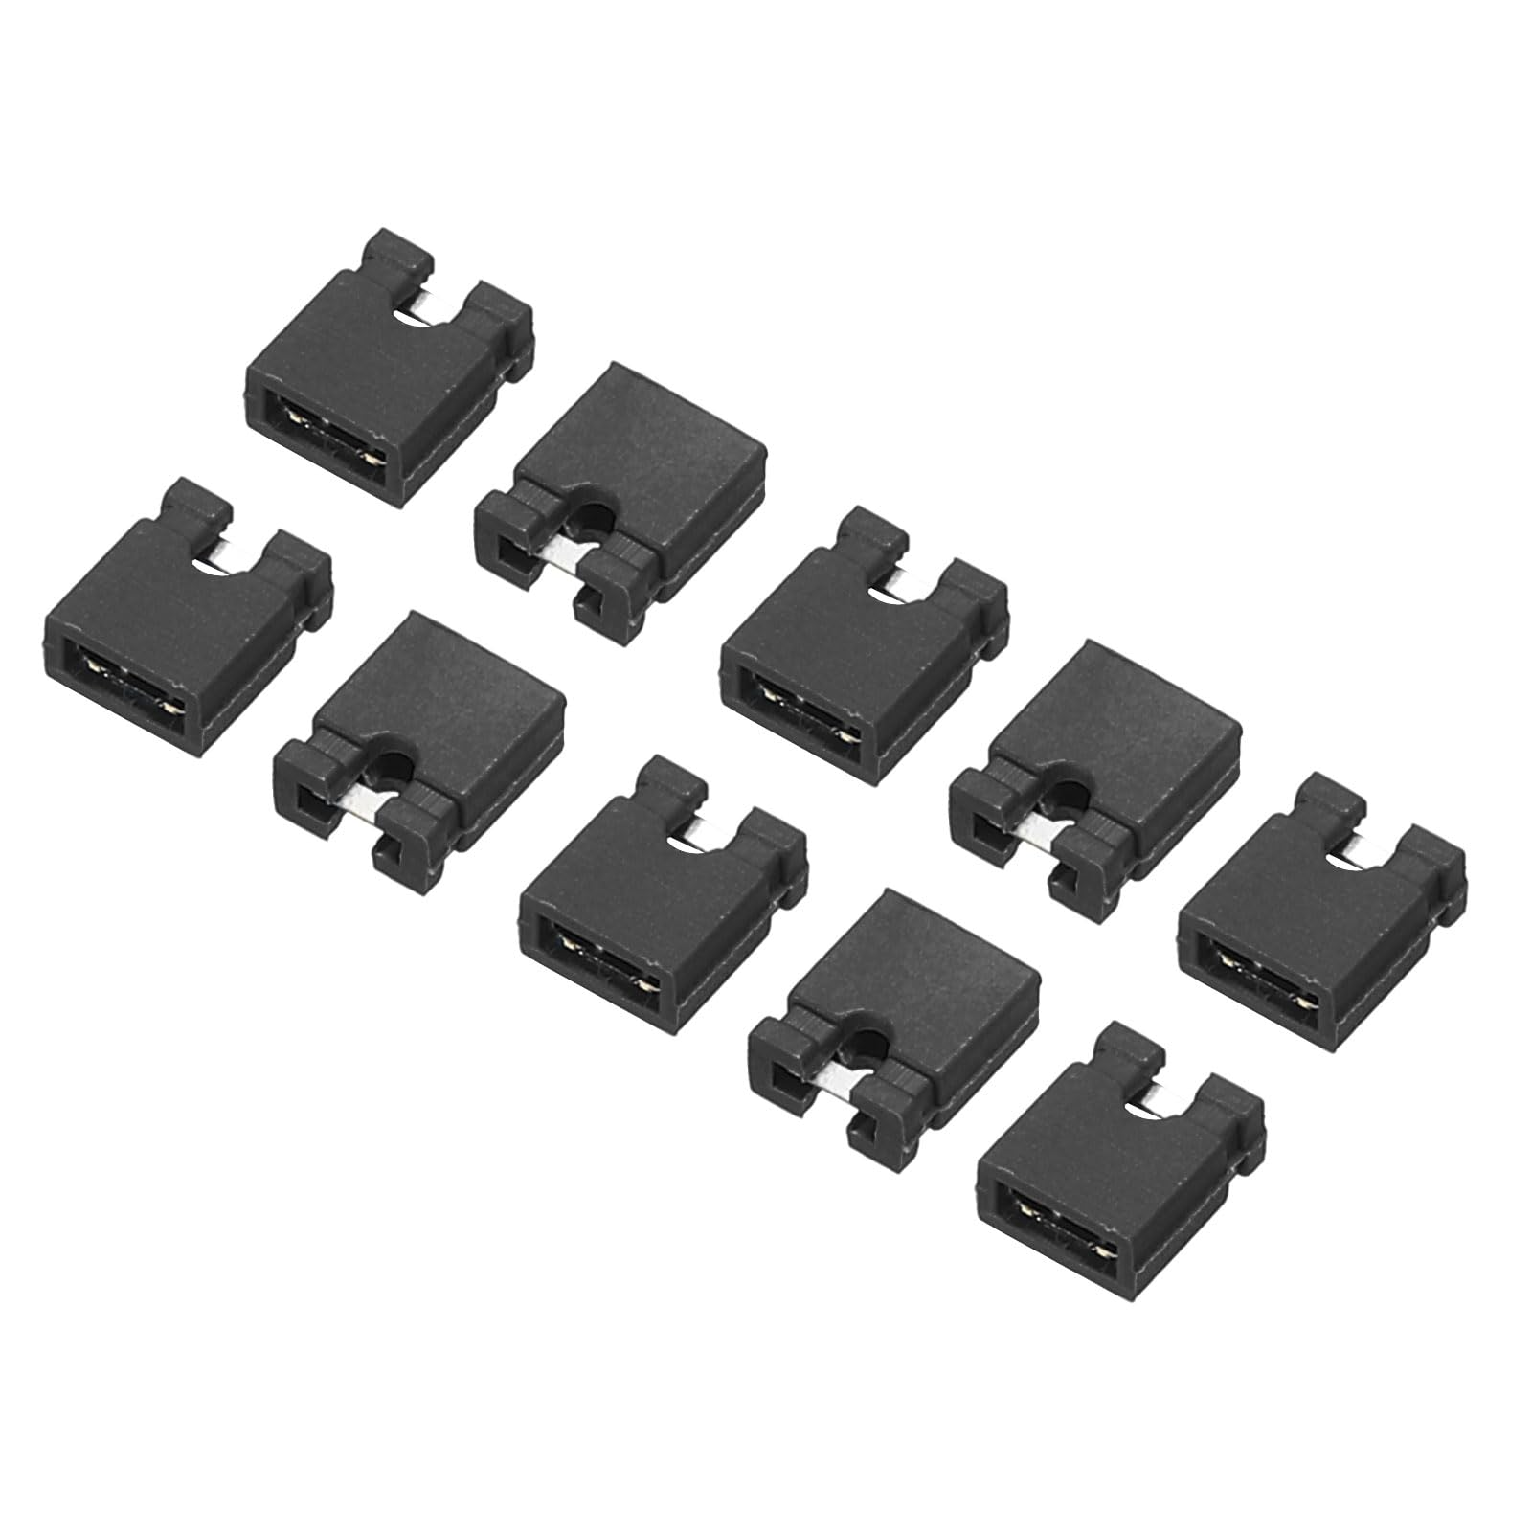
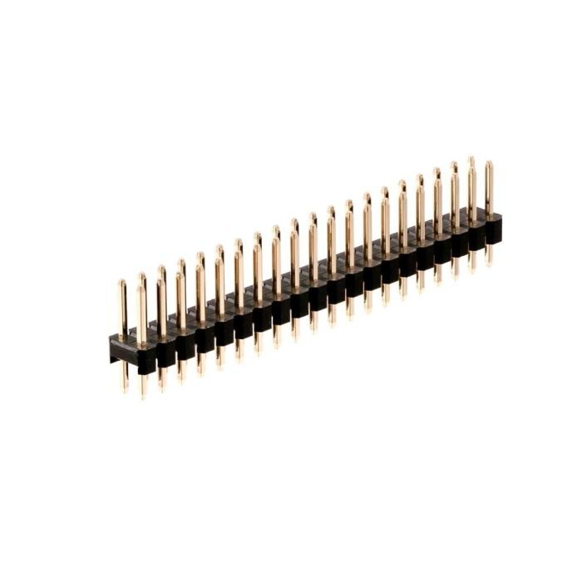
Additional Parts
- Silicone Thumbstick Analog Stick Joystick Cap - Small hole versions (larger hole caps are not compatible)

Reasons for improved Addressable LED power input.

Waveform of PWR_RAW input rail (v4.0).
- ~500mV peak to peak.
- This is the voltage we are feeding to the mini-badges VBAT pin.
- When the battery is 80 to 90% discharged this noise would couple through the LDO regulator to the ESP32.
- This noise creates an audible bussing sound due to the ceramic caps vibrating.
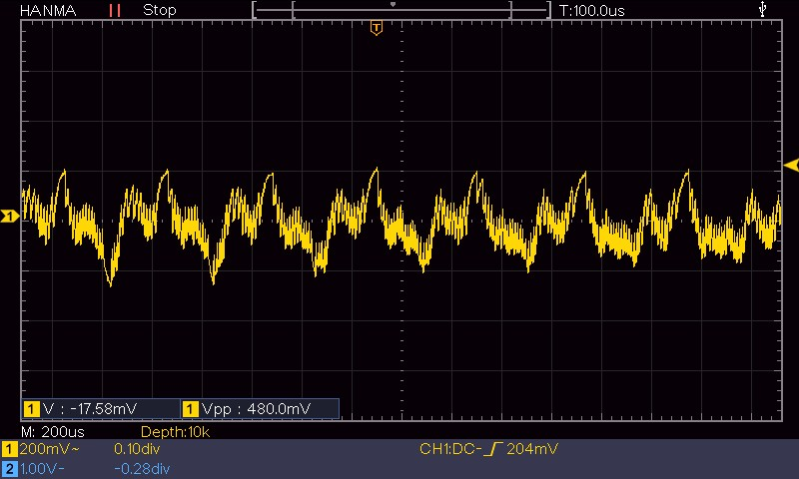

PWR_RAW waveform after adding RC filter to the Addressable LED's power input. Also switched from supplying the LEDs with 5V to directly from PWR_RAW rail (the LEDs self regulate so there is no need to regulate their input voltage).

